University of Washington

iSchool Info 330

# Module 07 Assignment - Final Milestone01

In this module's assignment, you will learn about data warehouse reporting databases and start the course final.

## Assignment Videos

Please watch the following Videos:

|  |
| --- |
| Assignment Videos < 120 min (Links are to external sites) |
| [Business intelligence in SQL Server 2016](https://youtu.be/UoEJ5m39s24) |
| [OLTP and OLAP Databases Designs](https://youtu.be/Nl88RGdSiZQ) |
| [Star and Snowflake Designs](https://youtu.be/h5LQZdmDjG4) |
| [Fact and Dimension Table Designs](https://youtu.be/34pEmQm7SDc) |
| [An Overview of Chapter 03 Exercises](https://www.youtube.com/watch?v=rr8nA17cWpI) |
| [An Overview of Chapter 04 Exercises](https://www.youtube.com/watch?v=9aTkwwZgbDY)  [Business Intelligence Tutorial](https://www.youtube.com/watch?v=jkCCnwvO_fg) |

## Assignment Examples

Read and try out some SQL statements on the Microsoft’s website. This website has short articles about many subjects. Although much more complex than the W3Schools website, this website will also become a "Go To" sites as you progress in your learning.

|  |
| --- |
| Examples < 60 min (Links are to external sites) |
| <http://en.wikipedia.org/wiki/Business_intelligence> |
| <http://en.wikipedia.org/wiki/Data_warehouse> |

## Assignment Reading

Since the course does not have an official text you will use various websites for your studies. This is a great way to learn new subjects and practicing it will be something you will use for years to come! Please read the following web pages:

|  |
| --- |
| Reading < 120 min (Links are to external sites) |
| ProSQL2012BISolutions_Ch01.pdf |

## Assignment Task

I want you to practice what you have learned in the course about the creation of relational databases. So, in the Final, you design, implement, test, and document a database used by an application being developed by another team. This project will be done in Milestones, with this week’s assignment being Milestone01.

**NOTE: See the Info 330 - Class Final.docx file for details**

### Milestone 01: Design

For Milestone01 you need to design a database using metadata spreadsheet and an ERD.

Open the provided Excel spreadsheet " ***MetaData.xlsx***” and fill in the items needed to describe your database design (Figure 1).

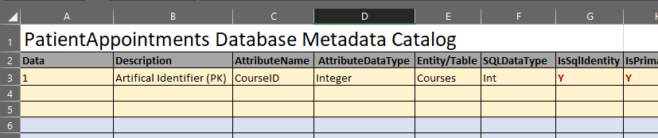

***Figure 1: The current metadata in the MetaData.xlsx file***

Create a Database Diagram for your newly designed database. Here is an **incomplete and possible incorrect** example I created using PowerPoint and Word (Figure 2).

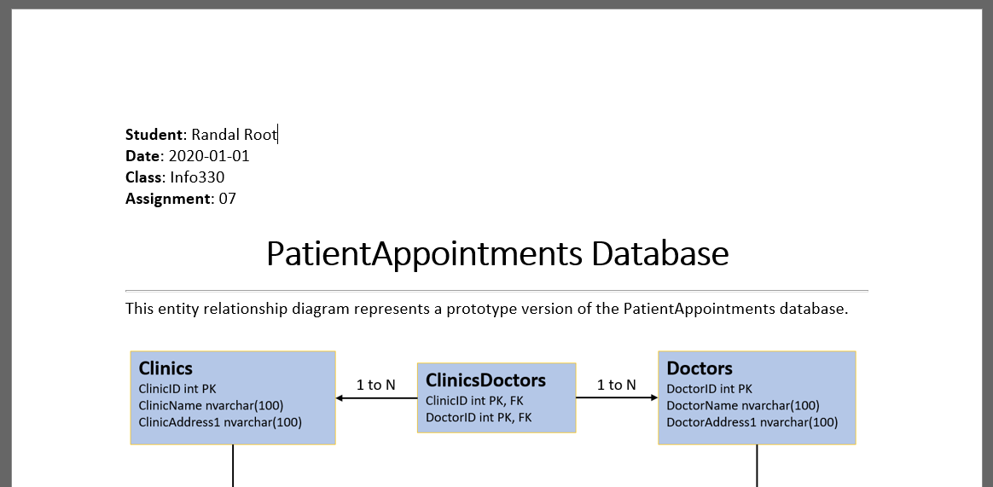

***Figure 2: The ERD in a Word document***

***Note:*** *There are several ways this database can be designed. If your design is similar examples you've seen and fits the rules of normalization, then you have done well.**Design it like you think it should be designed, but be prepared to explain why your answer is correct!*

You can use any tool you want to create the diagram, but once it is done, paste an image of it into a document for submission.

# Grading

Student work will be evaluated on a point system using the following general guidelines found on the Course Syllabus page. Make sure you read and understand this.

**NOTE:**  It is very possible to get a 3.9 or better from this course, but you have to earn it! Do not expect to get 100% of the possible points without extra effort on your part. If you want to excel in this course, you must submit **excellent**work!

# Submit your work

After you have completed your ERD Word document and Excel Metadata Spreadsheet, all into a folder called Assignment07**FirstInitialLastName** and Zip the folder. Upload the Zipped folder to the Canvas web site.

